

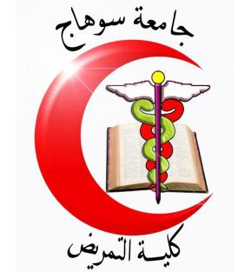

Quiz Exam of maternal and child health Nursing
Second Years Students
Date: 7/11 /2017 High Institution of Nursing
Time: 1 hrs Total Marks: 10 Marks
Define :-
- High risk neonate
------------------------------------------------------------------------------------------------------------------------------------------------------------------------------------------------------------------------------------------------------------------------------------------------------------------
- Growth
---------------------------------------------------------------------------------------------------------------------------------------------------------------------------------------------------------------------------------------------------------------------------------------------------------
II- Put (T) in front of the correct statement and (F) in front of the false one:

1- An infant of a diabetic mother is a baby not born to a mother who has diabetes. | T | F
2- Respiratory distress syndrome (RDS) is another name for hyaline membrane disease (HMD). It is defined as ineffective respiratory function resulting from lack of pulmonary surfactant. | T | F
3- chronic diseases affecting growth and development | T | F
IV-Read the words in column (A) and Wright the it's correct number at the relevant statement in column (B) :
Column (A) | Column (B)
1- Development  7-Pediatric Nursing | ( ) - It is aroused when the infant is subjected to light.  ( ) - giving assistant , caring and support to the growing and developing children o achieve their individual potential for functioning with fullest capacity  ( ) - refers to progressive increase in skill and capacity of function.

GOOD LUCK
Dr. Manal Mohammed Ahmed

